

Installation Guide:
ALT-YD-CCAM2010-LED-(All)
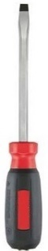
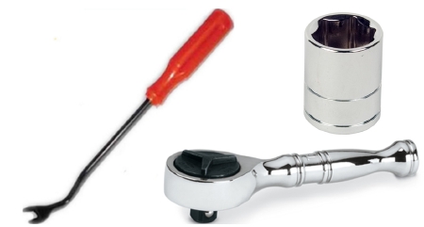
Tools Needed:
- ¼” ratchet
- Panel popper
- 10mm socket
- Flathead Screwdriver
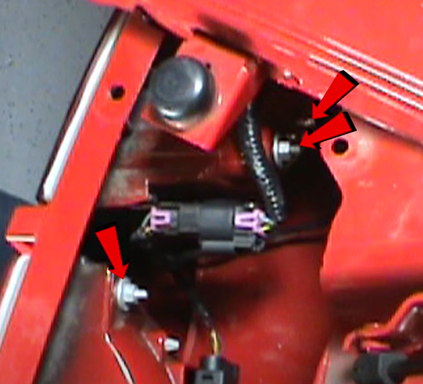
- Remove cover and set aside. Remove (4x) 10mm nuts.
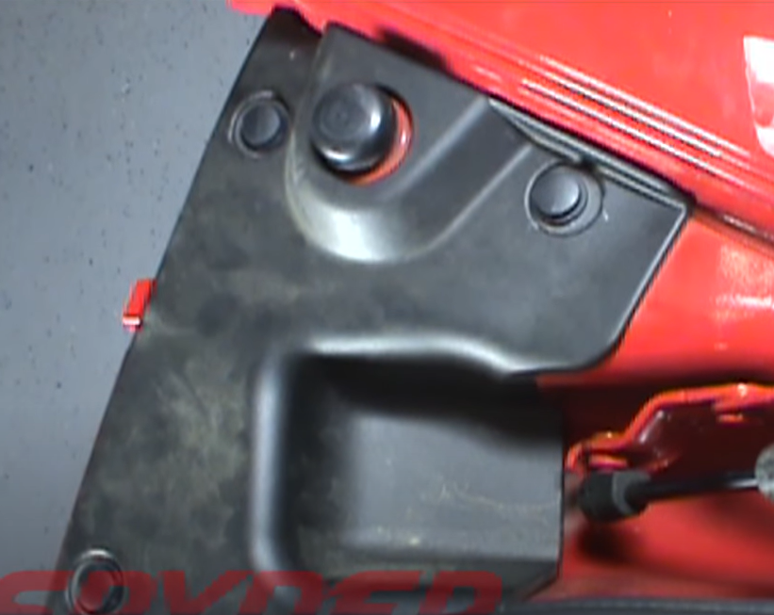
- Remove (3x) plastic retainers.

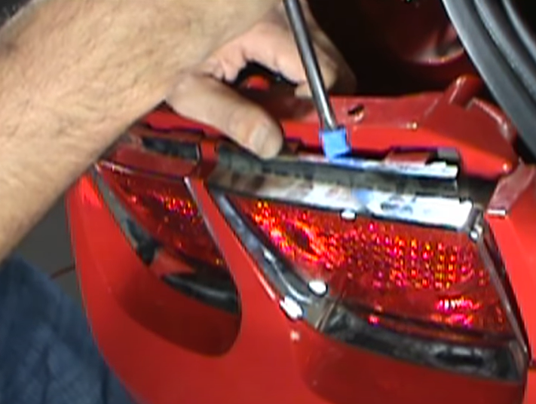
- Release (6x) retainer tabs to remove each bezel.
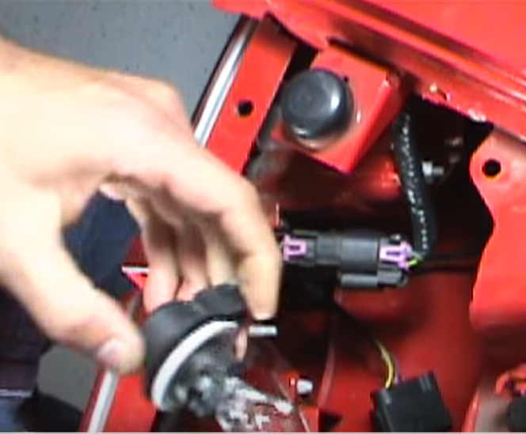
- Remove inner and outer brake lamp socket.

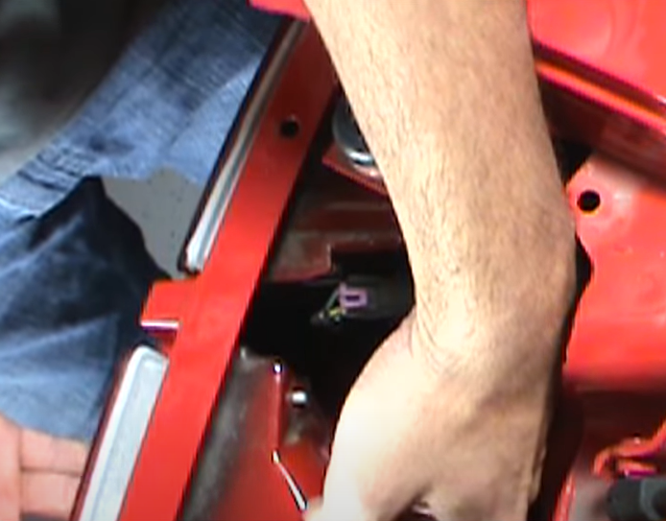
- Remove inner and outer tail light.
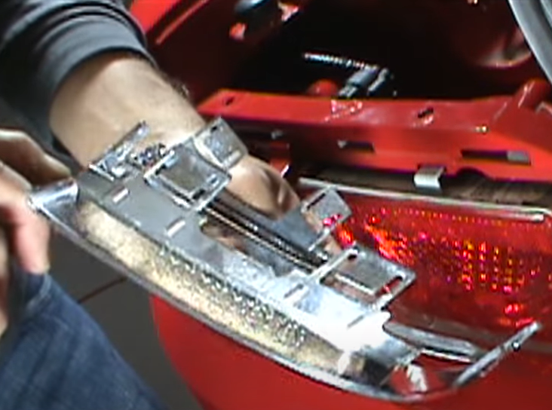
- Remove (2x) tail light bezels.

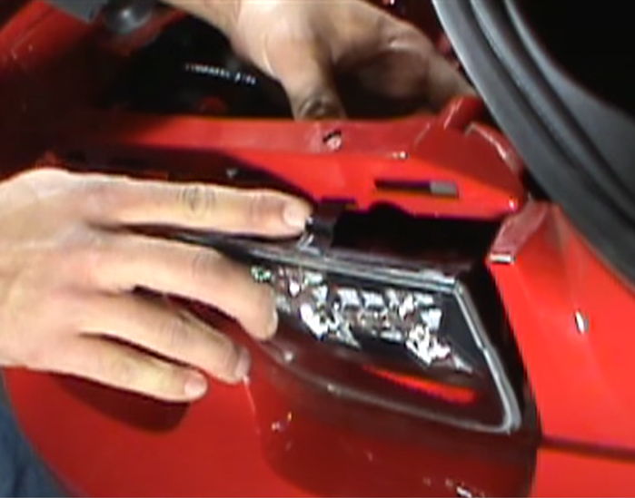
- Seat Spyder inner and outer tail lights making sure to seat guide tabs.
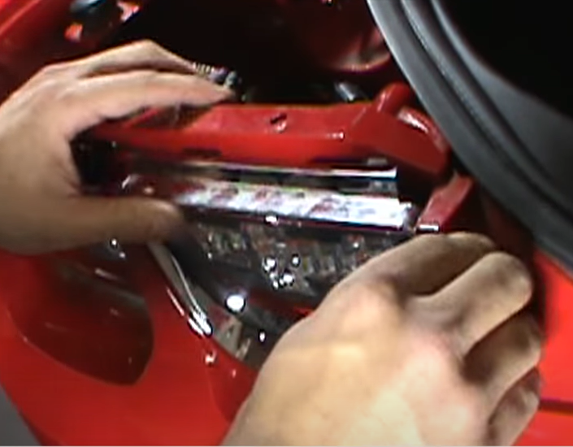
- Reinstall (2x) tail light bezels.

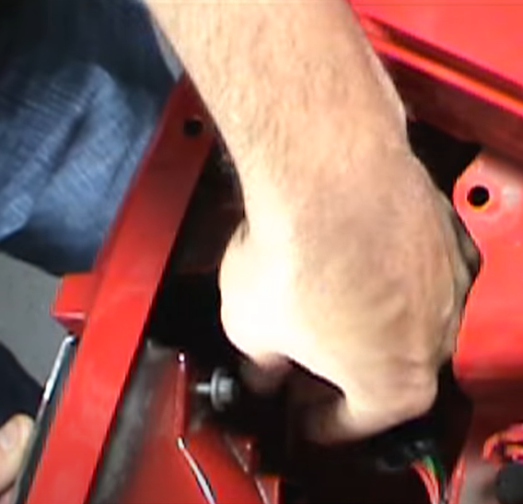
10. Reinstall (4x) 10mm nuts.
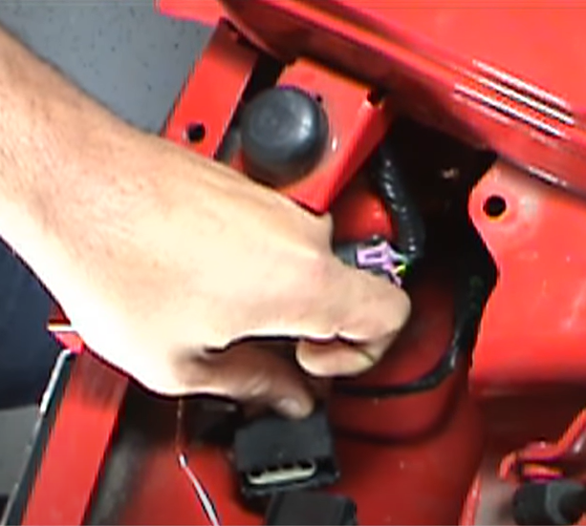
9. Connect inner and outer tail light harness to Spyder tail lights.

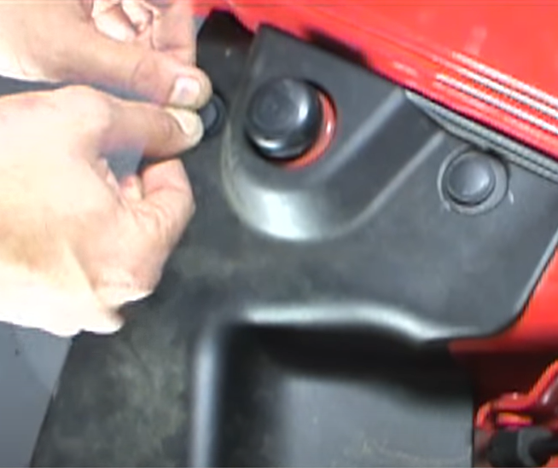
11.Reinstall cover panel and (3x) plastic retainers.
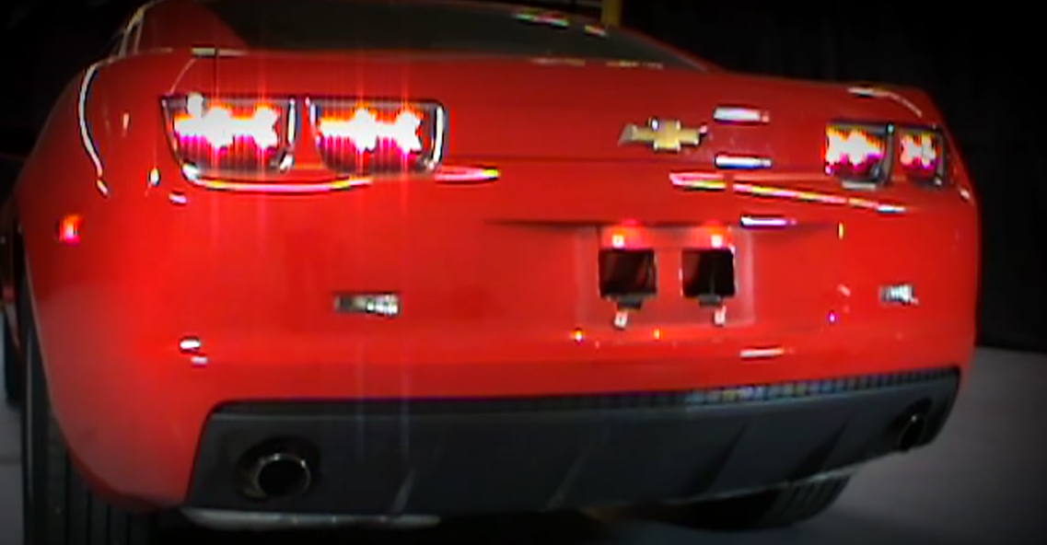
12. Turn on lights and confirm all functions are working properly. You have successfully completed the install of your new Spyder LED tail lights.

For further help with installation, please watch our installation video. Follow the direct link below to our YouTube channel for more information:
http://www.youtube.com/watch

DISCLAIMER
Spyder Auto Installation Guide is not liable for damages, injuries, and death while installing the product. This is intended to be an installation guide, to reduce installation time. We have no responsibility for improper installation. If you do not know how to install, please have a professional install it.

